West Virginia University Institute of Technology

Seasonal changes of nitrogen dioxide (NO2) from warming ocean waters effects the biomass of high nucleic acid (HNA) bacteria.

by

Bridget Browning

Biology 461

Dr. Jonathan Mitchell

April 1, 2023

**Abstract:**

This paper discusses the importance of nitrogen fixation in marine environments. Nitrogen fixation is an important factor for evolutionary biology because nitrogen is a requirement for all living things. In the mid 1900’s it was discovered that bacterial chemoautotrophs were a major component in marine nitrogen cycle. Biologist have been monitoring the increase of temperatures brought on from the impact of global warming. They have found that it has become an issue for marine environments and their diversity. Biologist use ecological principals known as ASR and TSR to monitor changes in bacteria. This paper analyzes data that was taken over a ten-year period. The data included temperature from all four seasons, the measurement of nitrogen content present at that time, and the abundance of HNA bacteria biomass. The hypothesis that changes in NO2 from the increase of ocean’s temperature would cause a reduction in HNA bacteria’s biomass was not supported from the statistical analysis.

**Introduction**

Nitrogen fixation is a vital role in the regulation of plankton production. Major components of the marine nitrogen cycle was discovered by the mid-1900s in such that bacterial chemoautotrophs known as nitrifiers played an important role in the marine nitrogen cycle (Hutchins & Capone, 2022). Nitrogen fixation is thought to have evolved first in archaea and then later transferred to bacteria. Biologist have been studying climate change and how it affects ecosystems and their living oceans biomass. Within the system heterotrophic prokaryotes make up most of the biomass and is clustered into two different groups based on their nucleic acid content. These are classified into low (LNA) and high (HNA) nucleic acid bacteria. The HNA are generally bigger than LNA. Biomass is measured in combination with abundance and size. Usually biologist will apply ecological principles that higher abundance is closely associated with smaller size known as the abundance-size rule (ASR). Another principle they consider is the higher the ambient temperature it will likely result in smaller individuals known as the temperature size rule (TSR). These two rules help to explain changes in planktonic heterotrophic bacteria (Moran, et al., 2015).

This study will go through data that was collected from 2003-2012 that will be able to provide us with some insight to the relative biomass size of HNA over the years to see if any affects from temperature and nitrogen had any impact. Based on the principles stated above I would assume that if the temperature did in fact show an increase over those ten years then the biomass of the bacteria should result in a smaller size according to the TSR rule. We can also look to see if there are any differences among the seasons to see if the biomass of HNA varies among the time of year. Since nitrogen fixation is a major component of the marine ecosystem this study aids to test the hypostasis that seasonal changes of nitrogen dioxide (NO2) from warming ocean waters effects the biomass of high nucleic acid (HNA) bacteria.

**Materials & Methods:**

Using the data collected from a 2015 study “More, smaller bacteria in response to ocean’s warming”, by Moran et al PRSB. This study will compare the biomass of HNA across the seasons for each of the years from 2003-2012. A statistical ANOVA analysis was used to see if there are any differences among the seasons. Since biomass is the main concern, a statistical Welch two sample t-test was done to see if there were any differences between 2005 and 2009 data on the biomass because those two years showed the largest difference in seasonal temperatures.

**Results:**

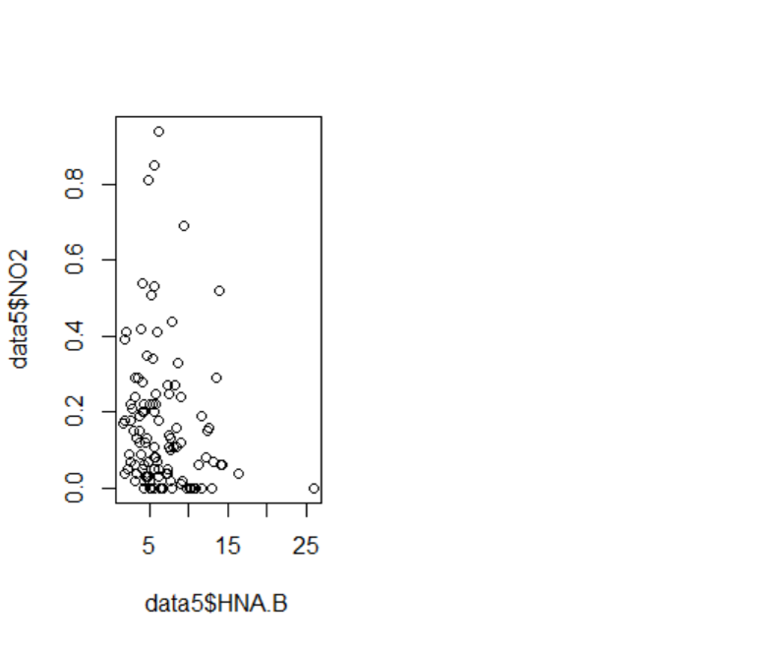Looking at the season plot that is in Figure 1 it shows that season 2 and 4 has the most variance in the size of HNA bacteria over the years. According to this in the summer of 2005 the amount of HNA topped the chart being the highest 14 ug CL-1 record of numbers and the record of lowest 4 ug CL-1 biomass that winter. The winter of 2009 ranked the highest of winters biomass at 10 ug CL-1. The Welch t-test results in Table 1 revealed that the mean of x 7.605455 and the mean of y 7.593333, t = 0.0054815, and a p-value = 0.9957.

Figure 2: Biomass of HNA to the NO2

Figure : Seasonal plot of HNA biomass from 2003-2012

Figure 2 shows the biomass size of the HNA bacteria that is measured in ug C L-1 units to that of the amount of nitrogen per umol L-1. The data reports that the bulk of the biomass is found approximately around 5ug per the 0.0-0.2umols of nitrogen.

Table 1: Welch two tailed t-test

|  |  |  |
| --- | --- | --- |
| t = 0.0054815 | df = 14.18 | p-value = 0.9957 |
| Sample estimates: mean of x (7.605455) mean of y (7.59333) | | |

**Discussion:**

In the study “The biomass distribution on Earth”, explained how biologist measure the prokaryotes cells biomass. The average cell concentration is calculated and then the total number of marine prokaryotes are estimated through multiplication by the water volume in each depth range they measure. The total number of cells is then converted to biomass by using the characteristic carbon content per marine prokaryote (Phillips & and Milo, 2018). Marine organisms are dependent on the ability of bacteria to be able to fix nitrogen by oxidation. The marine nitrogen cycle aids in denitrification, where dissolved NO3is reduced to N2 gas through a series of intermediates. As most marine organisms that require nitrogen for nutrition cannot assimilate either N2O or N2, denitrification generally results in a net loss of N from the system (Hulth, et al., 2005). The results from the Welch’s two sample t-test showed us that in the years of 2005 and 2009 which had the largest difference in seasonal temperatures had a p-value 0.9957. So, since that p-value is not less than the significance level of p=0.05 then the data tested in this study failed to reject the null hypothesis. The data that was given does not show any changes in the biomass from the amount of nitrogen dioxide levels. This means that the results of the NO2 did not affect the HNA bacteria’s biomass during the most drastic period of temperature changes during the ten-year study from 2003-2012. From this we can conclude no significant increase in the ocean’s temperature during the given time and there was no reduction in the biomass of the HNA bacteria leading us to the belief that the TSR rule is true.

**Data Accessibility:** Deposited in Dryad manuscript ID <http://dx.doi.org/10.506/dryad.kh7nt>

**Acknowledgements:**

I would like to personally thank Dr. Jonathan Mitchell from the West Virginia University Institute of Technology biology department for creating the graphs that was used in this study.

**Work Cited**

V. O. Sadras, P. T. Hayman, D. Rodriguez, M. Monjardino, M. Bielich, M. Unkovich, B. Mudge, E. Wang "Interactions between water and nitrogen in Australian cropping systems: physiological, agronomic, economic, breeding and modelling perspectives," Crop and Pasture Science, 67(10), 1019-1053, (19 September 2016)

Hutchins, D. A., & Capone, D. G. (2022). The marine nitrogen cycle: New developments and global change. *Nature Reviews Microbiology*, *20*(7), 401-414. <https://doi.org/10.1038/s41579-022-00687-z>

Martha Santos, Helena Oliveira, Joana L. Pereira, Mário J. Pereira, Fernando J.M. Gonçalves, Tânia Vidal, Flow cytometry analysis of low/high DNA content (LNA/HNA) bacteria as bioindicator of water quality evaluation, Ecological Indicators, Volume 103, 2019, Pages 774-781, ISSN 1470-160X, <https://doi.org/10.1016/j.ecolind.2019.03.033>. (<https://www.sciencedirect.com/science/article/pii/S1470160X19302146>)

M., Y., Phillips, R., & Milo, R. (2018). The biomass distribution on Earth. *Proceedings of the National Academy of Sciences*, *115*(25), 6506-6511. <https://doi.org/10.1073/pnas.1711842115>

Hulth, S., Aller, R. C., Canfield, D. E., Dalsgaard, T., Engström, P., Gilbert, F., Sundbäck, K., & Thamdrup, B. (2005). Nitrogen removal in marine environments: Recent findings and future research challenges. *Marine Chemistry*, *94*(1-4), 125-145. <https://doi.org/10.1016/j.marchem.2004.07.013>

RStudio Team (2020). RStudio: Integrated Development for R. RStudio, PBC, Boston, MA URL http://www.rstudio.com/.